CACHE Modules on Energy in the Curriculum
Fuel Cells
Module Title: Non Steady-State Carbon Diffusion in Solid Oxide Fuel Cell Interconnects
Module Author: Michael D. Gross
Module Affiliation: Department of Chemical Engineering
Bucknell University, Lewisburg, PA 17837

Course: Science of Materials (Introduction to Materials Science)
Text Reference: Callister and Rethwisch, Fundamentals of Materials Science and
Engineering: An Integrated Approach, 3rd edition (2008)
Sections 6.4-6.5

Concepts Illustrated: Non Steady-state diffusion; diffusion time as a function of temperature, distance, surface concentration, target concentration, and initial concentration.

Problem Motivation: Fuel cells are a promising alternative energy conversion technology. There are numerous types of fuel cells, as described in Module 0, which are typically distinguished (and named) by either 1) the ion conducted across the electrolyte or 2) the electrolyte material. The solid oxide fuel cell (SOFC) is one type of fuel cell that operates at high temperatures (600°C-1000°C). While most fuel cells can only operate on high purity H₂ fuel, the high temperature of SOFCs allows operation with synthesis gas (a mixture of H₂ and CO).

A general schematic of a SOFC operating on a mixture of H₂ and CO fuel is shown in Figure 1. Oxygen from air supplied to the cathode is reduced to O²⁻ at the cathode, transported across the electrolyte, and reacted with H₂ and CO fuel at the anode releasing electrons. The electrons released at the anode are transported through an external circuit where electrical power can be drawn.

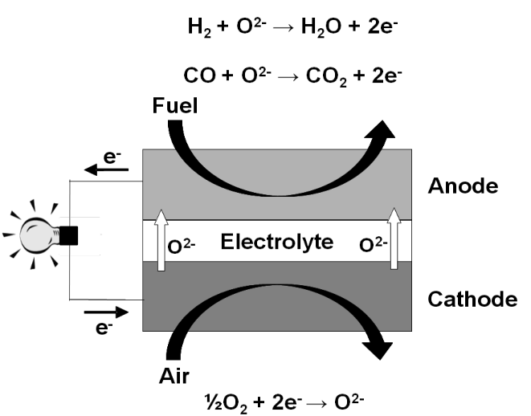
SOFC H₂ reactions:

Anode: H₂ + O⁻² → H₂O + 2 e⁻
Cathode: ½ O₂ + 2 e⁻ → O⁻²
__________________________________________________
Overall: H₂ + ½ O₂ → H₂O

SOFC CO reactions:

Anode: CO + O⁻² → CO₂ + 2 e⁻
Cathode: ½ O₂ + 2 e⁻ → O⁻²
__________________________________________________
Overall: CO + ½ O₂ → CO₂
Figure 1. General schematic of SOFC.

Stacking Fuel Cells in Series
One major advantage of fuel cells is that scaling fuel cell systems to meet specific power requirements is relatively easy, ranging from small portable applications to large stationary applications. Scaling fuel cell power is achieved by simply stacking fuel cells in series as schematically shown in Figure 2.
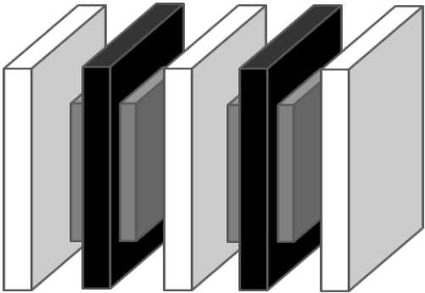

Electrolyte
Cathode
Anode

Interconnect
Fuel Cell

Figure 2. Schematic of two fuel cells stacked in series.

When fuel cells are stacked in series, the anode and cathode must be separated so that the fuel-rich atmosphere in the anode and oxygen-rich atmosphere in the cathode do not mix. The component that separates the anode and cathode is called an interconnect. For SOFCs designed to operate at relatively high SOFC operating temperatures (800°C-1000°C), interconnects are composed of expensive ceramic materials such as La_{1-x}Sr_{x}CrO₃ (strontium-doped lanthanum chromite). At relatively low SOFC operating temperatures (less than 800°C), steels can be used for interconnects, which is advantageous due to the low cost. Steel interconnects cannot be used at temperatures greater than 800°C due to significant corrosion called metal dusting.

Corrosion: Metal Dusting
Metal dusting is a severe form of corrosion that occurs when susceptible materials are exposed to an environment with high carbon activity. During the metal dusting process, carbon uptake occurs in the metallic phase, which leads to supersaturation of carbon in the steel. Eventually the carbon precipitates into a graphitic carbon within the steel resulting in the formation of loose filmentous carbon and metallic particles. These loose particles look like dust on the surface of the steel (which is why it is called metal dusting) and over time, significant amounts of steel are lost.
Metal dusting is an important consideration for SOFC steel interconnects because mixtures of H₂-CO-H₂O-CO₂ occur on the anode side of the interconnect and this mixture of gases has a high carbon activity.
In this module, the non steady-state diffusion of carbon into various steels will be investigated. This is an important consideration for SOFC interconnects because above a critical carbon concentration in the steel, metal dusting will occur.

Non steady-State Diffusion
Non steady-state diffusion applies to many circumstances in materials science. During non steady-state diffusion, the diffusion flux and concentration gradient are a function of time. (In the case of steady-state diffusion, the diffusion flux and concentration gradient are constant over time.) Non steady-state diffusion can be described by Fick’s 2nd Law, Eqn. 1.
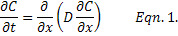
where C = concentration, t = time, x = distance and D = diffusion coefficient (or diffusivity).
The diffusion coefficient indicates the ease with which a species can diffuse in some medium (this module considers the diffusion of carbon into steel). Diffusion is a thermally activated process and so it is appropriate that the diffusion coefficient takes the form of the Arrhenius equation as shown in Eqn. 2.
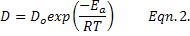
where D_{o} = pre-exponential constant, E_{a} = activation energy for diffusion, R = ideal gas constant, and T = temperature in Kelvin.
If the diffusion coefficient is independent of composition (which we will assume for this module), then Eqn. 1. can be simplified to the following:
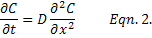
In materials science, it is common to model non steady-state diffusion as a semi-infinite solid where the surface concentration is held constant as shown in Figure 3.
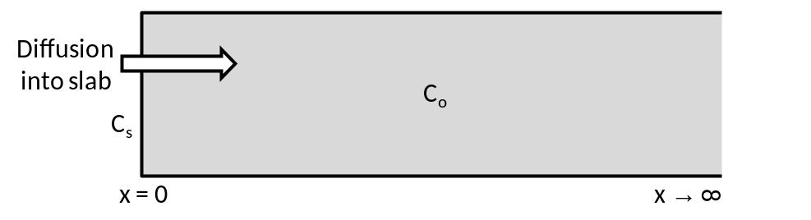

Figure 3. Modeling Non Steady-State Diffusion with a semi-infinite solid geometry.

In Figure 3,
C_{s} = surface concentration
C_{o} = initial concentration in the solid
C_{x} = concentration of diffusing species in the solid at some distance and some time
x = distance into the solid

For this module, the solid will be various steels and the diffusing species will be carbon.
In order to solve Fick’s 2nd Law for a semi-infinite solid, several assumptions have to be made and boundary conditions have to be defined.
Assumptions:
- Prior to the start of diffusion, any diffusing species in the solid are uniformly distributed throughout the solid.
- x = 0 at the solid surface and increases with distance into the solid.
- t = 0 the instant before diffusion begins.

Boundary Conditions:
- For t = 0, C = C_{o} at 0 ≤ x ≤
- For t > 0, C = C_{s} at x = 0
- For t > 0, C = C_{o} at x =

With these boundary conditions and assumptions, the solution to Eqn. 2. is as follows:
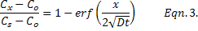
The term is the called the Gaussian error function. Values can be found in Table 6.1 of Callister and Rethwisch or calculated with a computing tool such as Matlab, Polymath, or Excel.

Problem Information
Example Problem Statement:
You have been asked to evaluate three types of steel for use as an SOFC interconnect: 304L, 316L, and 347L. The “L” stands for low carbon concentration and is defined as having a carbon concentration of 0.03 wt%. (Most steels have a carbon concentration of 0.08 wt%, but can be as high as 0.15 wt%.) The SOFC is designed to operate on a mixture of H₂ and CO fuel with an effective carbon activity of 1.1 wt%. Significant interconnect metal dusting will occur when a critical carbon concentration of 0.08 wt% is reached at some defined distance into the interconnect. In order to evaluate the effectiveness of the steels, you are asked to do the following:
- Investigate the effect of temperature on the time it takes to reach the critical carbon concentration of 0.08 wt% 0.5 mm into the steel. Consider a temperature range of 600°C-800°C.

- Investigate the time it takes to reach a critical carbon concentration of 0.08 wt% at various distances into the steel at a temperature of 600°C. Consider 0.1 mm ≤ x ≤ 1.0 mm.

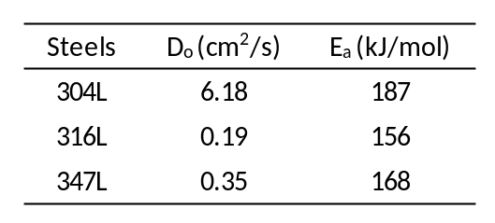
Necessary Information:

Assumptions:
- Model diffusion with a semi-infinite solid geometry.
- Diffusion coefficient is independent of composition.

Example Problem Solution:
Part 1.
Example calculations are shown for 304L steel at a temperature of 600°C. The example calculations are followed by results for all three types of steel for the entire temperature range under consideration.
Approach.
The diffusion of carbon into the various steels can be calculated with Fick’s 2nd Law.
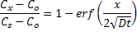
We were given C_{x} = 0.08 wt% which are all temperature independent values.
C_{s} = 1.1 wt%
C_{o} = 0.03 wt%
x = 0.5 mm

The diffusion coefficient, D, is a function of temperature and therefore must be calculated for each temperature considered. Once D is known, we can solve for time, t.
Step 1.
Calculate D for 304L at 600°C.
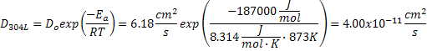
Step 2.
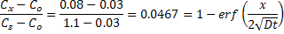
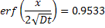
Step 3.
The value of can be estimated by linear interpolation of the error function table in Callister and Rethwisch (Table 6.1) or determined by calculating the inverse error function with a computing tool.
For , 1.4064
Note that the inverse error function value, 1.4064, is the same for all calculations because C_{s,} C_{o}, and C_{x} are constant in this problem.
Side note: The inverse error function can be directly calculated in Matlab, however, the inverse error function does not exist in Excel. For Excel, sqrt(gammainv(p,0.5,1)) will return the inverse of erf(p).
Step 4.
Calculate t.
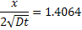
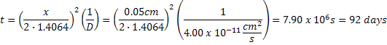
Step 5.
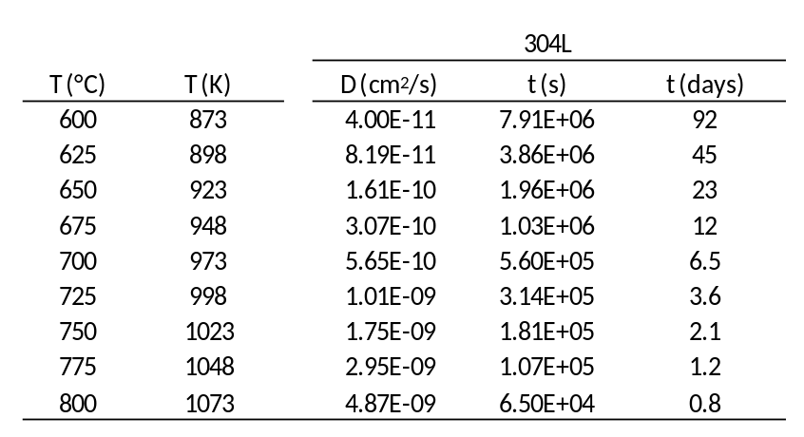
Similar calculations for 304L, 316L, and 347L as a function of temperature yield:

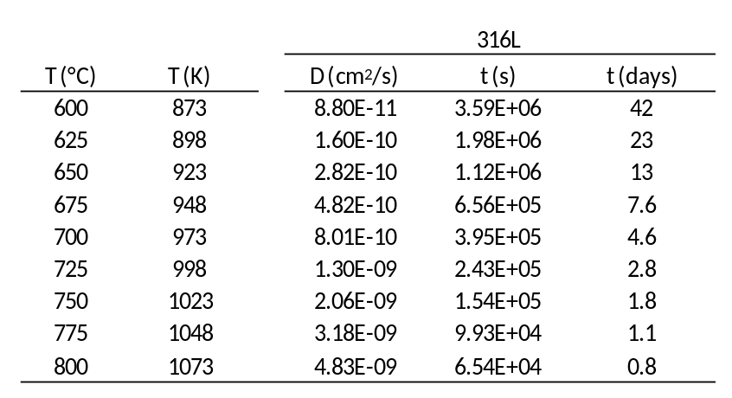

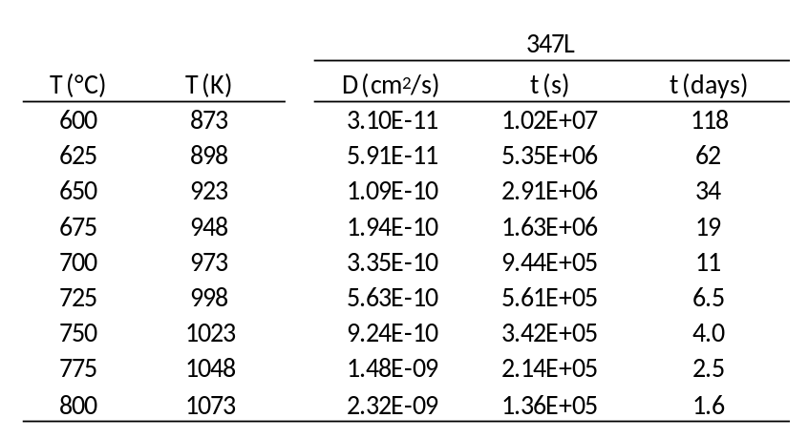

Step 6.
For a more visual comparison, diffusion time is plotted as a function of temperature for the three steels with both a linear scale and log scale.

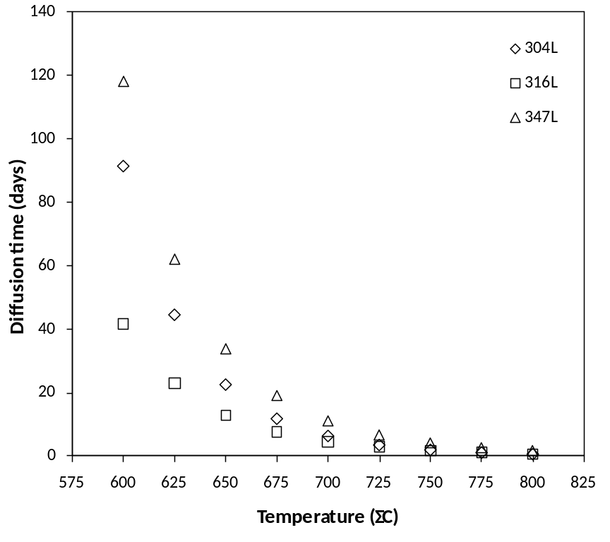

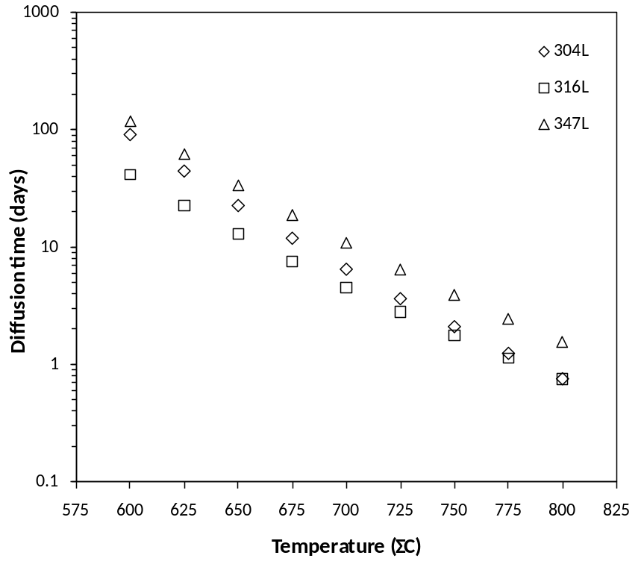

Summary
The 347L steel is the most resistant to metal dusting. As can be seen from the plot with the linear scale, diffusion time rapidly increases as temperature decreases. This is expected because the diffusion coefficient is a thermally activated process and follows the Arrhenius equation.

Part 2.
Example calculations are shown for 304L steel for x = 0.1 mm. The example calculations are followed by results for all three types of steel for the entire range of “x” under consideration.
Approach.
The diffusion of carbon into the various steels can be calculated with Fick’s 2nd Law.
We were given C_{x} = 0.08 wt%
C_{s} = 1.1 wt%
C_{o} = 0.03 wt%
T = 600°C

The diffusion coefficient, D, is a function of temperature and therefore must be calculated for 600°C. Once D is known, we can solve for time, t, over the range of x to be considered.
Step 1.
Calculate D for 304L at 600°C.
Step 2.
Step 3.
The value of can be estimated by linear interpolation of the error function table in Callister and Rethwisch (Table 6.1) or determined by calculating the inverse error function with a computing tool.
For , 1.4064
Note that the inverse error function value, 1.4064, is the same for all calculations because C_{s,} C_{o}, and C_{x} are constant in this problem.
Side note: The inverse error function can be directly calculated in Matlab, however, the inverse error function does not exist in Excel. For Excel, sqrt(gammainv(p,0.5,1)) will return the inverse of erf(p).
Step 4.
Calculate t for x = 0.1 mm.
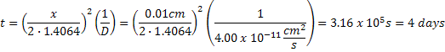

Step 5.
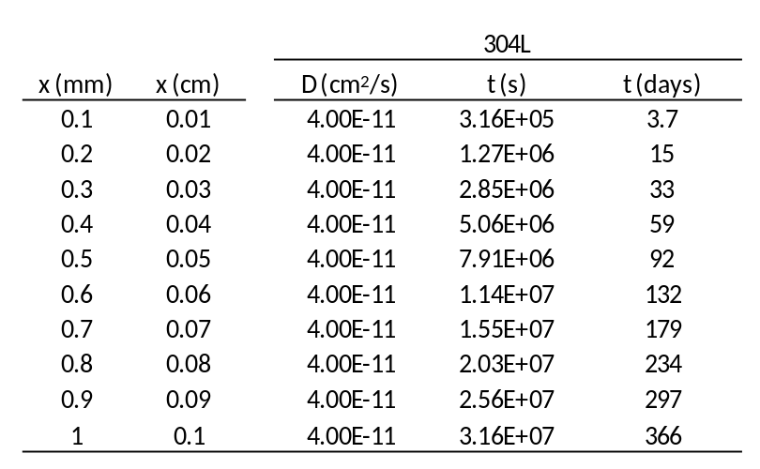
Similar calculations for 304L, 316L, and 347L as a function of x yield:

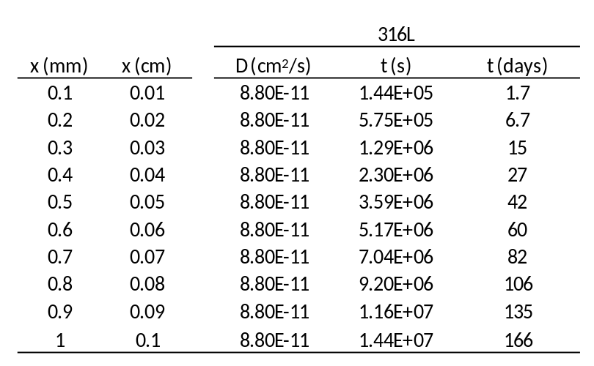

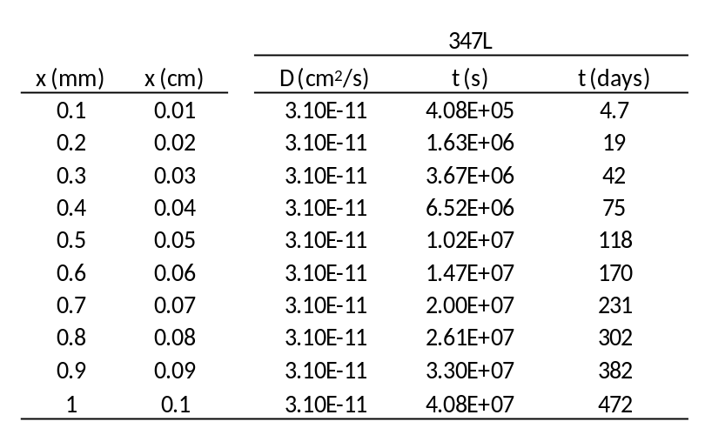

Step 6.
For a more visual comparison, diffusion time is plotted as a function of x for the three steels.
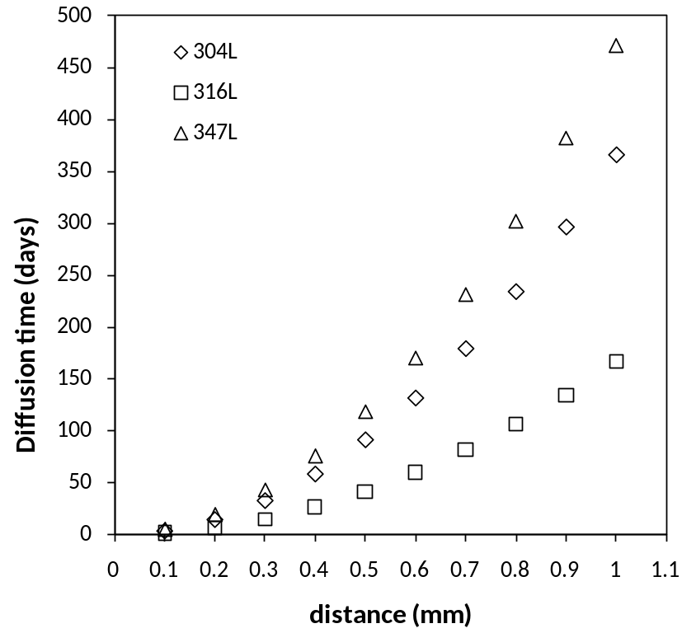

Step 7.
For this problem, C_{S}, C_{o}, and C_{x} were constant, which means that
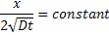
which leads to
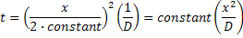
For a constant temperature, D is also constant.
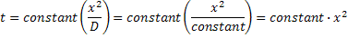
Therefore, diffusion time is proportional to x², which is consistent with our results.

Summary
The 347L steel is the most resistant to metal dusting. As can be seen from the plot, diffusion time is proportional to x² for a constant temperature.

Home Problem Statement:
You have been asked to evaluate three types of steel for use as an SOFC interconnect: 304L, 316L, and 347L. The “L” stands for low carbon concentration with a typical carbon concentration of 0.03 wt%. (Most steels have a carbon concentration of 0.08 wt%, but can be as high as 0.15 wt%.) The SOFC is designed to operate at 600°C on a mixture of H₂ and CO fuel. Significant interconnect metal dusting will occur when a critical carbon concentration is reached 0.5 mm into the interconnect. In order to evaluate the effectiveness of the steels, you are asked to do the following:
- Investigate the effect of the fuel’s carbon activity (i.e. the effective surface concentration of carbon, C_{s}) on the time it takes to reach a critical carbon concentration of 0.08 wt% 0.5 mm into the steels. Assume the initial carbon concentration throughout the steel is 0.03 wt%. Consider 0.1 wt% ≤ C_{s} ≤ 1.1 wt%.

- Investigate the effect of critical carbon concentration (i.e. C_{x}) on the time it takes to reach the critical carbon concentration 0.5 mm into the steels. Assume C_{s} = 1.1 wt% and C_{o} = 0.03 wt%. Consider 0.05 wt% ≤ C_{x} ≤ 0.45 wt%.

- Investigate the effect of initial carbon concentration in the steel (i.e. C_{o}) on the time it takes to reach a critical carbon concentration of 0.08 wt% 0.5 mm into the steels. Assume C_{s} = 1.1 wt%. Consider 0 wt% ≤ C_{o} ≤ 0.07 wt%.

Necessary Information:

Assumptions:
- Model diffusion with a semi-infinite solid geometry.
- Diffusion coefficient is independent of composition.

